Practical - 6

Aim:
Implement Program for fractional knapsack using Greedy design technique.

Code:

#include <stdio.h>

int sort(float ratio[], float weight[], float profit[], int n) {
for (int i = 0; i < n - 1; i++) {
for (int j = 0; j < n - i - 1; j++) {
if (ratio[j] < ratio[j + 1]) {
// swap ratio
float temp_ratio = ratio[j];
ratio[j] = ratio[j + 1];
ratio[j + 1] = temp_ratio;
// swap weight
float temp_weight = weight[j];
weight[j] = weight[j + 1];
weight[j + 1] = temp_weight;
// swap profit
float temp_profit = profit[j];
profit[j] = profit[j + 1];
profit[j + 1] = temp_profit;
}
}
}
}

float knapsack(float weight[], float profit[], int capacity, int n) {
// get profit/weight ratio and sort items by ratio in descending order
float ratio[n];
for (int i = 0; i < n; i++) {
ratio[i] = (float)profit[i] / weight[i];
}
sort(ratio, weight, profit, n);
float total_profit = 0;
for (int i = 0; i < n; i++) {
if (weight[i] <= capacity) {
total_profit += profit[i];
capacity -= weight[i];
} else {
total_profit += ratio[i] * capacity;
break;
}
}
return total_profit;
}

int main() {
int n;
printf("Enter the number of items: ");
scanf("%d", &n);
float weight[n];
float profit[n];
for (int i = 0; i < n; i++) {
printf("Enter weight and profit for item %d: ", i + 1);
scanf("%f %f", &weight[i], &profit[i]);
}
int capacity;
printf("Enter the capacity of the knapsack: ");
scanf("%d", &capacity);
float max_profit = knapsack(weight, profit, capacity, n);
printf("Maximum profit: %f\n", max_profit);

return 0;
}
Output:
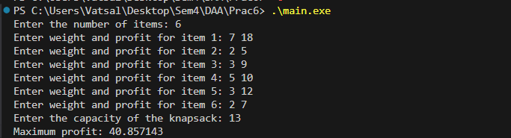
Analysis:
The greedy algorithm is the optimal solution for the fractional knapsack problem because items can be divided into smaller parts.
- Strategy: Calculate the value-to-weight ratio (v_{i}/w_{i}) for each item and sort them in descending order.
- Execution: Select the item with the highest ratio first. If it fits, take the whole item; if not, take the fractional portion that fills the remaining capacity.
- Time Complexity: O(n log n) due to the sorting step. The subsequent selection process takes O(n).
- Space Complexity: O(n) beyond storing the input.

Conclusion:
The fractional model is frequently applied in industries where resources are divisible or can be allocated proportionally:
- Logistics & Shipping: Optimizing cargo value for bulk materials like fuel, liquids, or powders.
- Finance & Portfolios: Allocating investment capital among various assets to maximize expected returns relative to risk.
- Resource Allocation in IT: Distributing CPU time or cloud storage among competing tasks.
- Disaster Relief: Prioritizing food and medicine supplies in humanitarian operations based on their weight efficiency.

